HoleOnSurface / HoleInDepth
Two holes can connect a part of a crack and any crack always consists of 2+ holes.

CrackOnSurface:
These cracks are parts of the mesh, that (are treated as if they) are already disconnected. It consists of an ordered series of Holes. Cracks can expand (METHOD), when the Idestructible is hit by a force.
The direction of the expansion is depended of cracks alignment (METHOD) and the relative position of the origin point of the force (PARAMETER). From this a possible area is calculated and the concrete position of expansion randomly chosen. If this possible area contains another crack, the expansion results in the connection of those cracks (or maybe an are bigger than the possible expansion area is checked for this).After merging, some possible events could happen, that need to be checked (something broke out? Were the now merged holes part of the same cracks or from two different ones?)
This expansion reduces the tension in the wall and therefore the force. Expansion is repeated until (force =< 0).

The borders of an Idestructible are treated as Cracks with the added information, if they are fixated or not (for example by a roof).

CrackInDepth:
Similar to CrackOnSurface (INTERFACE). Always expands away from the origin of force.
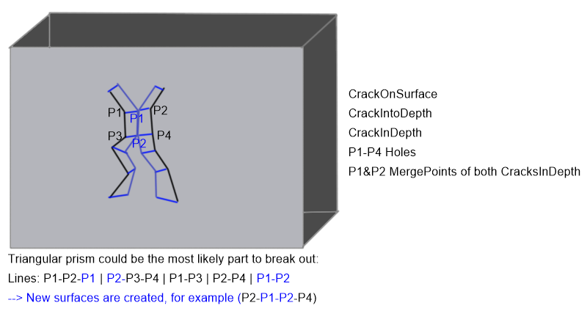
Special case, that could happen:
The Expansion of CracksInDepth happens similarily to the expansion of cracksOnSurface.

What needs to be regarded when managing those cracks:
What is a crack? There are things like splits, merging of two cracks and the alignment, which can be different for two (or more) parts of a crack. A good system for tracking the alignment of cracks is needed for the expansion method and for the "Hit-Event".

ForceDistributer
Every Hit generates a force, that effects the IDestructible. Each of these effects reduces the original Force until its zero. Force can also be reduced without a lasting effect (for example on the outlines of the wall). Distribution will probably work like this:
Create SupportPolygon.
Create areaForceDistribution (for example: First k neighbouring Grids/Cubes receive 30 % of Force, next k neighbouring Grids/Cubes receive 20 %...). For each of those groups of Grids/Cubes, the Force is distributed between the Cracks those Grids/Cubes contain.
This distributions does not happen evenly but with prioritizing based on position in relation to the supportpolygon! Otherwise it could easily happen that no crack expands because Force/numberOfCracks is too low.

Alternatively: Instead of areas, the Forcedistributer gets the five smallest SupportPolygons, and the Force is distributed between them (for example most likely gets 30 percent of Force, second most likely gets 20 percent and so on...).

In both cases the Force is first distributed between different sets of cracks (areas or SupportPolygons) and in those sets distributed between the cracks and its holes.

MeshCutter
This class cuts meshes along different planes and is informed/called when cracks form a polygon. After cutting something out of the mesh, the areas of the both new meshes, that are laid free need to be filled. Maybe this should be done by another new class.

